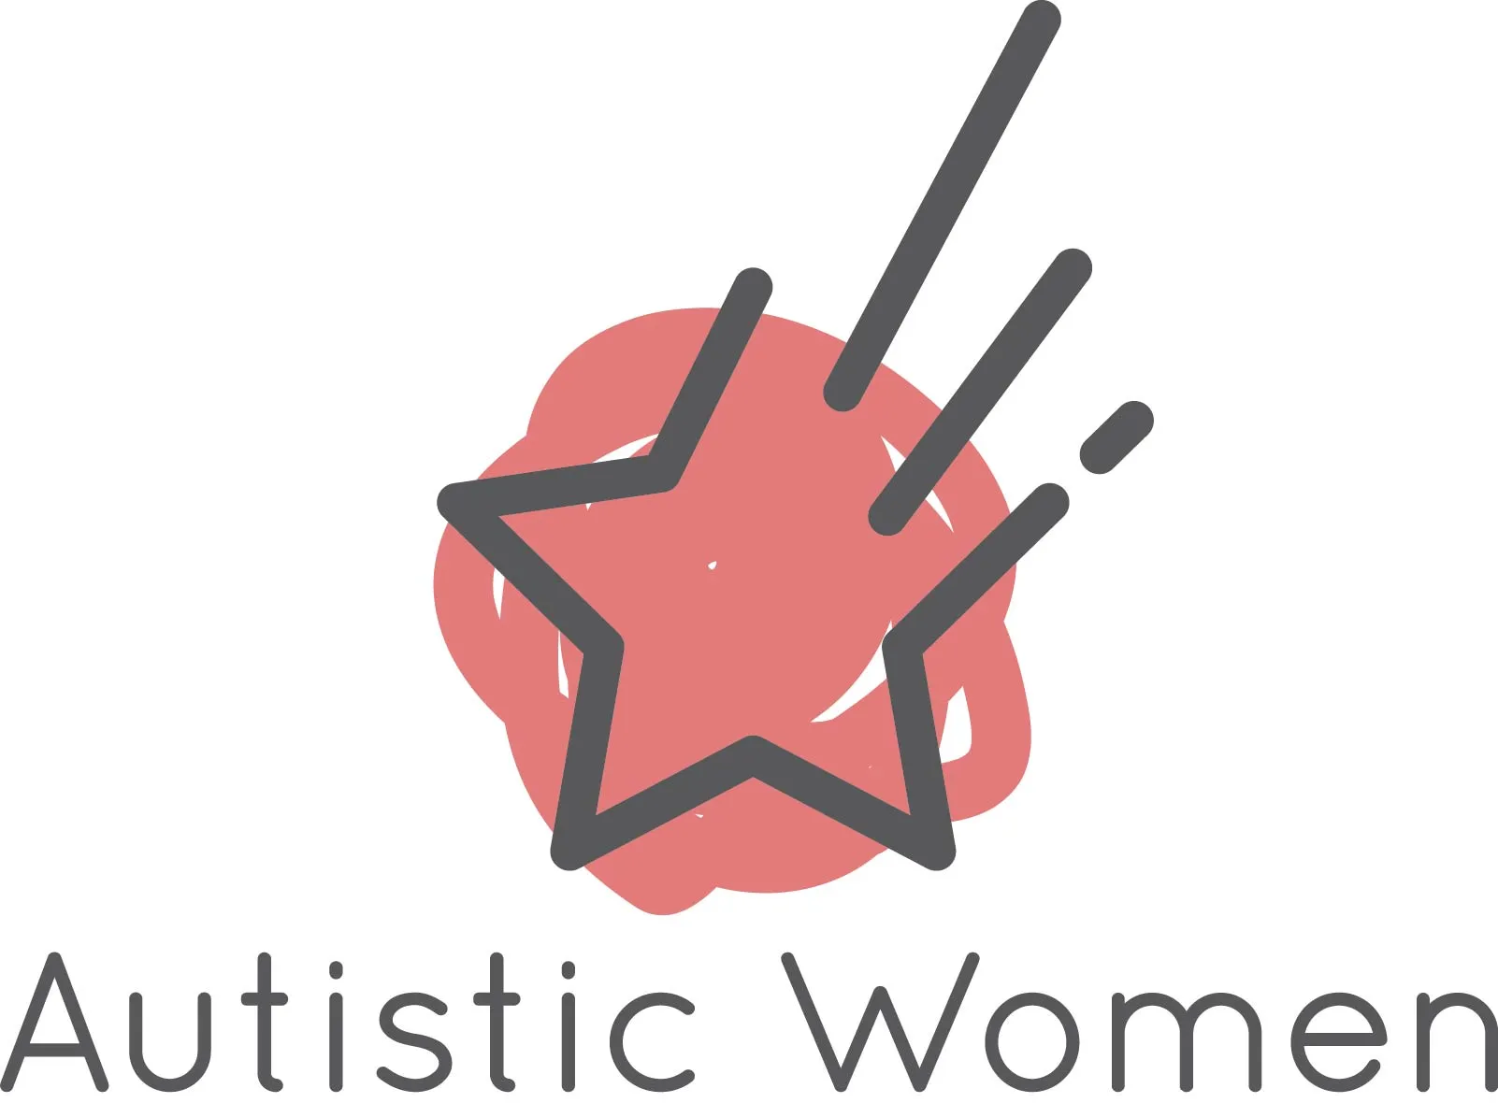

My Capacity Map
A gentle workbook for understanding what helps you feel more like yourself
The question isn’t always
“Should I be able to do this?”
It can be much more useful to ask:
“Do I have capacity for this right now?”

Name

Date started

Autistic Women

September 2026

How to use your Capacity Map
This workbook is an invitation to get curious about your own patterns — what stresses you, what soothes you, what stimulates you, and what helps you feel safe.
It isn’t a test. It isn’t a checklist of things you should be doing. Think of it as a way of collecting information about yourself.

Before you begin
You don’t have to complete this all at once. One section is plenty.
There are no right answers, and your answers may change.
Single words are fine. Nothing needs to be a full sentence.
You can type into this document, or print it and write by hand — whichever suits you better.
Your capacity is contextual
It can change depending on sleep, stress, relationships, sensory input, work, hormones, social contact, demands, interests, and what has happened recently.
The same thing can therefore be soothing one day and overwhelming another. Someone can feel safe in one context and stressful in another.
Start with your body
Before analysing something too much, notice what happens in your body. When you imagine doing something:
- Does it feel like a movement towards, or away?
- Warmer, or colder?
- Softer, or tighter?
- More open, or more contracted?

This isn’t about reducing every decision to yes or no. It’s simply another source of information.

The four questions
These four questions run through the whole workbook. You’ll be asked them of your relationships, your senses, your routines, your work — everything.

STRESS  What increases demand on my nervous system? | SOOTHE  What helps me settle, recover or feel safe?
STIMULATE  What brings energy, interest, excitement or focus? | SAFETY  Where and with whom can I be myself without performing?

A note about change
If you discover that something you once thought was soothing is actually draining you, that isn’t you getting it wrong.
It may be that your circumstances, your capacity, or your understanding has changed.

If something difficult comes up
Parts of this workbook touch on masking, rejection and needs that were dismissed. If a page feels like too much, skip it — that is a good decision, not an avoidant one.
This workbook is for reflection and self-understanding. It is not a substitute for individual support. If something surfaces that feels too big to hold alone, please talk to your GP, your therapist, or another professional you trust.
My capacity today
Before exploring the different domains, pause and notice where you are today.
How is my body feeling right now?
What sensations, tension, tiredness, energy or restlessness do I notice?
How full is my social battery?
Think about recent social contact, not just what you have planned today.
How full is my cognitive battery?
How much planning, organising, remembering, switching or decision-making am I carrying?
How safe do I feel?
Physically, emotionally and psychologically — what tells me that?
What do I need more of?
What do I need less of?

Come back to this page
Your answers here are a snapshot, not a verdict. On a different day they may look completely different — and that is exactly the information you are collecting.
You may want to print a few copies of this page, or repeat it whenever your capacity shifts noticeably.
1. Relationships & social connection
Relationships can have a huge impact on capacity. This isn’t about how many relationships you have — it’s about how your relationships feel.

STRESS  What increases demand on my nervous system? | SOOTHE  What helps me settle, recover or feel safe? | STIMULATE  What brings energy, interest, excitement or focus? | SAFETY  Where and with whom can I be myself without performing?

People who stress me
Who leaves me feeling depleted, anxious, judged, pressured, or as though I need to perform?
People who soothe me
Who allows me to be myself, be quiet, ask for what I need, or simply exist without performing?
People who stimulate me
Who brings energy, curiosity, laughter, shared interests or deep conversation?
Contexts matter
Is someone different for me in different settings? When does a relationship feel safer, or more stressful?
My social battery
How much social contact can I comfortably manage before I need recovery? What are my early signs that I’m reaching my limit?
Anything else I notice about this area?
Patterns, exceptions, things that don’t fit neatly into the four questions.
2. Sensory world
Your sensory environment can change your capacity significantly. Notice your different senses, rather than treating “sensory sensitivity” as one thing.

STRESS  What increases demand on my nervous system? | SOOTHE  What helps me settle, recover or feel safe? | STIMULATE  What brings energy, interest, excitement or focus? | SAFETY  Where and with whom can I be myself without performing?

Sight
What visual environments stress, soothe or stimulate me?
Sound
What sounds are difficult? What sounds help? When do I need quiet?
Touch & clothing
What textures, fabrics, pressure or physical contact affect me?
Smell, taste & temperature
What sensory experiences are particularly noticeable, or particularly regulating?
Movement & body sensations
What kinds of movement, pressure, rhythm or physical activity help me feel settled or energised?
Anything else I notice about this area?
Patterns, exceptions, things that don’t fit neatly into the four questions.
3. Routines, structure & predictability
Structure can reduce executive-function demands and create a reassuring rhythm. But too much rigidity can create stress of its own.

STRESS  What increases demand on my nervous system? | SOOTHE  What helps me settle, recover or feel safe? | STIMULATE  What brings energy, interest, excitement or focus? | SAFETY  Where and with whom can I be myself without performing?

What routines genuinely help?
Which routines make life easier because I don’t have to keep deciding what happens next?
Where does structure become restrictive?
Are there routines that feel driven by fear, urgency, or a need to prevent something bad happening?
My helpful baseline
What predictable elements would make my day easier without making it feel rigid?
What happens when plans change?
What helps me adapt when something unexpected happens?
Anything else I notice about this area?
Patterns, exceptions, things that don’t fit neatly into the four questions.
4. Cognitive load & demands
One of the biggest hidden drains on capacity can be the amount of thinking, planning, organising and switching you are doing.

STRESS  What increases demand on my nervous system? | SOOTHE  What helps me settle, recover or feel safe? | STIMULATE  What brings energy, interest, excitement or focus? | SAFETY  Where and with whom can I be myself without performing?

What is taking up mental space?
What am I remembering, anticipating, planning or worrying about?
What decisions can I remove?
What could become a default, routine, reminder, template, list or automation?
What demands are too high?
Where am I asking myself to plan, organise or switch more than my brain comfortably allows?
What can be made smaller?
Which tasks could be broken down, postponed, delegated, or done differently?
Anything else I notice about this area?
Patterns, exceptions, things that don’t fit neatly into the four questions.
5. Work, study & meaningful activity
Work can be demanding, but it can also be stimulating, meaningful and deeply aligned with your interests. Look at the whole picture.

STRESS  What increases demand on my nervous system? | SOOTHE  What helps me settle, recover or feel safe? | STIMULATE  What brings energy, interest, excitement or focus? | SAFETY  Where and with whom can I be myself without performing?

What drains me?
Consider cognitive, social, sensory, emotional and organisational demands.
What energises me?
Which tasks, topics or ways of working bring interest, focus or satisfaction?
How much switching is required?
How often am I interrupted, or expected to move rapidly between tasks?
What would make work more sustainable?
Think about autonomy, predictability, environment, communication, breaks, workload and protected focus time.
Anything else I notice about this area?
Patterns, exceptions, things that don’t fit neatly into the four questions.
6. Interests, focus & monotropism
Your interests aren’t something you need to apologise for. Focused interests can be a source of pleasure, regulation, connection and meaning.

STRESS  What increases demand on my nervous system? | SOOTHE  What helps me settle, recover or feel safe? | STIMULATE  What brings energy, interest, excitement or focus? | SAFETY  Where and with whom can I be myself without performing?

What naturally draws my attention?
What can I become deeply absorbed in?
What helps me recharge?
Which interests leave me feeling restored, or more like myself?
How much uninterrupted focus do I get?
What happens to my capacity when my attention is repeatedly interrupted or redirected?
What judgement do I carry?
Have I learned to minimise, hide or feel ashamed of the things that genuinely interest me?
Anything else I notice about this area?
Patterns, exceptions, things that don’t fit neatly into the four questions.
7. Demand, autonomy & PDA
For some autistic people, the experience of demand itself can create a powerful need to resist, avoid or escape — including demands connected to things they actually want to do.

STRESS  What increases demand on my nervous system? | SOOTHE  What helps me settle, recover or feel safe? | STIMULATE  What brings energy, interest, excitement or focus? | SAFETY  Where and with whom can I be myself without performing?

What happens when something becomes a “have to”?
Notice whether your capacity changes when an activity shifts from choice to obligation.
What creates more autonomy?
Would a different time, order, wording, environment or choice make the demand easier?
What is underneath the resistance?
Is it tiredness, overwhelm, fear, loss of autonomy, uncertainty, perfectionism — or something else?
What helps me feel I have a choice?
List the conditions that make action feel more possible.
Anything else I notice about this area?
Patterns, exceptions, things that don’t fit neatly into the four questions.
8. Hormones & changing capacity
If you menstruate, your hormonal cycle may be one factor affecting energy, sensory sensitivity, social capacity and cognitive load. During perimenopause, patterns can also become more variable.

STRESS  What increases demand on my nervous system? | SOOTHE  What helps me settle, recover or feel safe? | STIMULATE  What brings energy, interest, excitement or focus? | SAFETY  Where and with whom can I be myself without performing?

My cycle patterns
When in my cycle do I notice changes in social, sensory, emotional or cognitive capacity?
What changes before menstruation?
What do I need more of? What becomes harder?
What happens after menstruation?
When do I notice capacity beginning to return, or change?
Hormonal changes
If relevant to me, which patterns have become less predictable?
What would it mean to plan around my capacity?
What could I change if I treated these patterns as information, rather than something to push through?
Anything else I notice about this area?
Patterns, exceptions, things that don’t fit neatly into the four questions.
Looking beneath the pattern
Sometimes our current responses are influenced by earlier experiences. If you have spent years masking, adapting, or having your needs dismissed, it can be difficult to know what is happening now and what belongs to the past.

Please take this section gently
You might find it useful to explore these questions with a trusted person or a therapist rather than alone.
There is no obligation to answer any of them. Leaving a page blank is a perfectly good outcome.
When did I learn that my needs were “too much”?
What did I learn I had to do to stay safe or accepted?
Which parts of me still expect rejection, criticism or abandonment?
Where do I notice myself automatically people-pleasing, masking or overriding my needs?
What would my present-day self choose, if I knew I was safe enough to choose?
My Personal Capacity Map
Bring your observations together here. You can add to this over time — and you don’t need to fill every box.

DOMAIN | STRESS | SOOTHE | STIMULATE | SAFETY
Relationships
Social contact
Sensory
Routines
Cognitive load
Work
Interests
Hormones

Patterns I’m noticing
Look across the grid. What repeats? What surprises you? What connects? Is there one change that would help more than the others?
My capacity decision tool
When you’re unsure whether to say yes, pause before answering from obligation. Work through these six questions.

1. What is my body saying?
Warmer or colder? Towards or away? Tense or settled?
2. What is using my capacity already?
Social contact, sensory input, work, cognitive load, emotions, hormones, poor sleep, uncertainty?
3. What will this demand actually require?
How long? How much social interaction? How much planning? How much sensory or cognitive effort?

4. Do I have enough capacity?
Yes / Not right now / Only if I change the conditions
5. What could make it easier?
Reduce, postpone, delegate, simplify, ask for help, change the environment, protect recovery time.
6. What do I actually want?
Separate your own preference from what you think you should do.

You rarely have only two options — yes exactly as asked, or no.
Try an easeful experiment
Choose one small change. You don’t need to redesign your whole life.
The change I want to try
Why I think it might help my capacity
What I will change
Be specific — when, where, how often.
What I predict will happen

What actually happened
Come back to this after a week or two.
What I learned about myself

However it turned out
An experiment that didn’t work is not a failure — it is information about what your nervous system actually needs.
You can run this page as many times as you like.
A gentle weekly check-in
Use this once a week, or whenever you notice your capacity changing. You may want to print several copies of these two pages.
What gave me energy this week?
What drained my capacity?
When did I feel most like myself?
When did I feel I had to perform or mask?

What helped me feel safe?
What did my body try to tell me?
What do I want more of next week?
What do I want less of next week?
A different question

You don’t have to keep proving that you can cope.
Your capacity is information.

The more you understand what stresses you, what soothes you, what stimulates you and what helps you feel safe, the more choices you have.
Easeful living isn’t about creating a life where nothing is difficult. It’s about creating enough understanding, flexibility and self-trust that you can respond to what you need — rather than continually overriding yourself.

So, before the next automatic yes — pause.
Do I have capacity?
And if the answer is no, the next question isn’t “What’s wrong with me?”
It is: “What would help?”

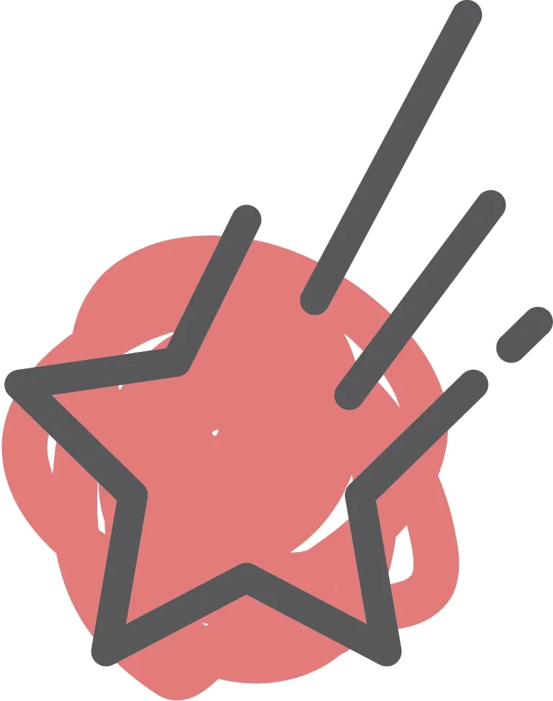
Autistic Women
This workbook is for reflection and self-understanding. It is not a substitute for individual therapeutic support.

© 2026 Autistic Women. This guide has been created for personal use. Please don't reproduce or distribute commercially without permission.

