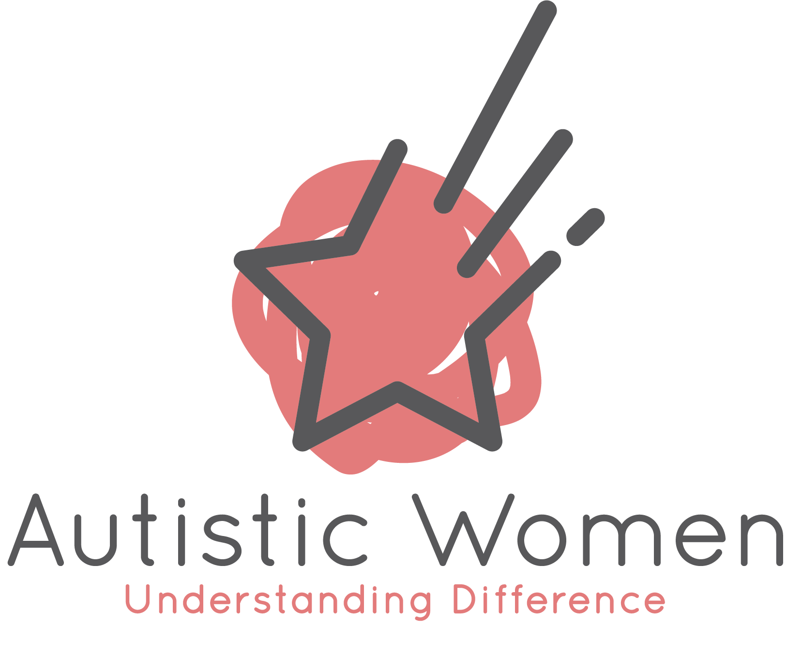

Living More
Easefully
A guide and workbook for autistic women
Learning to notice your capacity, understand what affects it, and make choices that fit you.
The question at the heart of this guide:
“Do I have the capacity for this right now?”

Written by Dr Becky Quicke
Founder, Autistic Girls and Women
September 2026

Before we begin
Many autistic women are completely exhausted, struggling with fluctuating energy levels and/or are in a state of burn out – or collapse as I prefer to call it. This guide won’t cover everything in relation to this, but it aims to give you some guidance as to how start living within your energy limits instead of outside of them.
To start living more easefully.
And it is centred around you asking yourself this essential question:
“Do I have the capacity for this right now?”

How to use this guide
This guide is here to be useful to you — not to be another demand. It is a mixture of ideas to read and think about, and space to write things down. You do not need to do it all, and you do not need to do it in order.

Some ways people use it
- Read it straight through once, without writing anything, just to see what resonates.
- Dip into one section at a time — perhaps one a week.
- Start with the section that resonates with you right now, and ignore the rest for the moment.
- Use only the Capacity Map and leave the reading for another day.

A few things worth knowing before you start
- There are no right answers here. You are collecting information about yourself, not being assessed.
- Nothing you write is permanent. Your answers will change with the day, the week, the season — that is the whole point.
- You can write in single words. Full sentences are not required. You can also draw, doodle or record your spoken thoughts.
- If a page feels like too much, skip it. Coming back to something later is a completely legitimate way to use this guide.

A note on the harder parts
Some sections touch on difficult experiences — including rejection, bullying and harm in relationships. They are there because they are part of many autistic women’s lives, and understanding them can be useful. If reading about them is not what you need today, please move past them. That is a good decision, not an avoidant one.

If you want support alongside this guide
This guide is for reflection and self-understanding. It is not therapy and it is not a substitute for individual support. If something surfaces that feels too big to hold on your own, please talk to your GP, your therapist, or another professional you trust.

PART 1 — Understanding your capacity

1. The question that changes things
What if, instead of continually asking yourself:
- “Why can’t I cope with this?”
- “What’s wrong with me?”
- “How do other people manage all of this?”
“Do I have the capacity for this right now?”

For me, this is at the heart of living more easefully as an autistic woman.
You might have a better word than ‘capacity’. A physical representation can be helpful. Such as ‘spoons’, which suggests you have a finite number of spoons available.
It sounds like a simple question. But answering it well requires quite a lot of self-understanding — and some difficult unlearning of internalised beliefs about what you should be able to manage.

Capacity isn’t fixed
Your capacity changes depending on:
- what is happening around you, and what has happened recently
- how much demand you are carrying
- how safe you feel
- your sensory environment
- your relationships
- your hormones
- your cognitive load
- how much social interaction you have had
- whether you have had time to do things that genuinely restore you
- … and probably a whole load of other things too
This is where easeful living becomes much more interesting than simply trying to “do less”. It is about learning what works for your nervous system. It is about understanding yourself well enough to make decisions based on your actual capacity, rather than what you — or the world around you — think you should be able to manage.

Pause and notice
What is my capacity like today?
___________________________________________________________________
___________________________________________________________________
___________________________________________________________________
What am I currently carrying that may be affecting it?
___________________________________________________________________
___________________________________________________________________
___________________________________________________________________

2. Your body as a signpost (for those who get strong body feelings)
We often make decisions from our heads. We think things through. We weigh up the pros and cons. We consider what other people might think. We think about what we should do.
But when we are trying to understand capacity, it can be really helpful to start somewhere else:
“What is my body telling me?”

Your body may already know something your thinking brain hasn’t quite caught up with.

Things to notice
- Does the thought of this feel warmer or colder in your body?
- Do you soften, expand or relax when you imagine doing it?
- Or do you tense, contract, feel heavy, or want to get away?
This isn’t about making every decision a simplistic yes or no. Life is much more nuanced than that. But noticing whether something feels like a move towards or a move away can give you really useful information.
And if you have spent years learning to ignore your own needs, it may take time to hear those signals again. That is normal. It is not a sign you are doing it wrong.
You may still decide to do the ‘thing’ for various reasons, but knowing beforehand how your body feels about it gives you information about what support you might need before, during and after.

Try it
Think of something coming up in the next week. Before you think it through — what does your body do when you imagine it?
___________________________________________________________________
___________________________________________________________________
___________________________________________________________________
What does your body seem to be telling you?
___________________________________________________________________
___________________________________________________________________
___________________________________________________________________

But also remember, this does not work for everyone. Some autistic people get no or very subtle signals from their body and that is fine. Or sometimes it takes longer to process and tune into the body. There are other ways that will be covered throughout the rest of this guide.

3. The three Ss
When answering “Do I have capacity?” one place to start is understanding yourself. One way of doing this is to start noticing three things across different areas of your life.
WHAT STRESSES ME? | WHAT SOOTHES ME? | WHAT STIMULATES ME?
What increases demand on my nervous system?  What do I need to recover from? | What helps my nervous system settle, recover and feel safe? | What brings energy, interest, excitement, focus or engagement?

These aren’t fixed categories
- Something stimulating one day might be overwhelming on another.
- Something that usually soothes you might become irritating when you are already overloaded.
- Something that looks “good for you” from the outside might actually be exhausting.
There isn’t a universal list of things autistic women should do to regulate themselves. You need to understand your own nervous system — not follow someone else’s list.

The next part of this guide will focus on some areas of our lives and apply the 3 Ss to them all…

PART 2 — Three domains of capacity

1. Social capacity
For many autistic women, social relationships are one of the biggest influences on capacity. We are social mammals — our sense of safety is profoundly influenced by our relationships and our environment.
But our social needs don’t necessarily look like the stereotypical idea of having lots of friends, being socially active, or maintaining a large network. For some autistic women, psychological and emotional safety might be found with one person, or a very small number of people.
The question isn’t “How many people do I have in my life?”
It is: “Who do I feel safe being myself with?”

And perhaps just as importantly: “Who leaves me feeling depleted, anxious, judged, or as though I need to perform?”

Who stresses you?
- Who makes you feel as though you need to mask?
- Who leaves you questioning yourself?
- Who expects you to behave in ways that don’t feel natural?
- Who creates uncertainty or unpredictability?
- Who do you find yourself recovering from?

Who soothes you?
- Who allows you to be quiet?
- Who doesn’t require you to perform?
- Who understands when you need space?
- Who makes you feel accepted rather than assessed?
- Who can sit alongside you without needing you to fill the silence?
- Who leaves you feeling more like yourself?

Who stimulates you?
- The people you can talk to for hours about something you are interested in.
- The people who make you laugh.
- The people who spark ideas and curiosity.
- The people who energise rather than deplete you.
These categories will overlap — and that’s fine. Someone can be incredibly stimulating but exhausting. Someone can be deeply soothing but not particularly stimulating. Someone might feel safe in one context and stressful in another. And your experience of a person can change over time.
This isn’t about labelling people as permanently “good” or “bad”. It’s about becoming curious about your experience.

Your social capacity
Who currently gives me a sense of safety?
___________________________________________________________________
___________________________________________________________________
___________________________________________________________________
Who currently uses a lot of my capacity?
___________________________________________________________________
___________________________________________________________________
___________________________________________________________________
What kind of social contact feels most possible when my capacity is low?
___________________________________________________________________
___________________________________________________________________
___________________________________________________________________

Learning to recognise safety
This can be particularly complicated for autistic women. Many women who have spent years masking, adapting and trying to fit in have learned to disconnect from their internal signals. Sometimes that has been a survival strategy.
If expressing a need repeatedly resulted in rejection, criticism, shame or dismissal, it makes sense that you might eventually stop listening to that need.
There is a painful irony here: learning not to listen to yourself might have helped you survive social situations in the past — but it can also make it harder to recognise when something isn’t safe for you now.

What this can look like
- You might know intellectually that someone is “nice”, while your body feels uncomfortable around them.
- You might tell yourself a relationship is fine because nothing obviously terrible is happening — while noticing you consistently feel exhausted after seeing that person.
- You might struggle to explain why something feels wrong.
You don’t need a perfectly rational explanation before you are allowed to pay attention to your own experience.
Sometimes the first step is simply: “Something in me doesn’t feel comfortable here.”
That is information.

Safety
Is there a situation, or a person, where your body says something different from your head?
___________________________________________________________________
___________________________________________________________________
___________________________________________________________________
What does genuine safety feel like in my body?
___________________________________________________________________
___________________________________________________________________
___________________________________________________________________

When there’s deeper work to do
For many autistic women, understanding current relationships isn’t just about what is happening today. Our previous experiences influence how we respond to relationships now.
Many autistic women have experienced rejection, bullying, exclusion, shame, abuse, or relationships in which their needs were dismissed. There can also be a greater vulnerability to interpersonal and sexual violence.
It reflects the social vulnerability created when someone doesn’t fit comfortably within the expectations of the world around them — particularly when they have learned to mask their needs and prioritise other people’s comfort.
So sometimes the question isn’t simply: “Who makes me feel safe?” It is also: “Which parts of me are responding to what is happening now, and which parts are responding to what happened then?”

Working with “parts” of yourself
Therapeutic approaches that help you understand different parts of yourself can be useful here. You may have developed different ways of relating to people at different points in your life. Perhaps:
- a part that keeps everyone happy
- a part that expects rejection
- a part that wants to escape
- and another part that knows what you actually want
Understanding these parts can help you make decisions from your present-day self, rather than automatically responding from old protective strategies.
This is often work that is easier to do with support rather than alone. If this section stirred something up, that is worth taking seriously — and worth taking to someone you trust and maybe exploring within therapy.

Your social battery matters too
Sometimes the issue isn’t the person at all. You might genuinely enjoy someone’s company and still not have the capacity to see them.
This is an important distinction — and a kind one. It means a “no” is not a verdict on the relationship.

Ask yourself
- How much social contact have I had recently?
- How full or empty is my social battery?
- How much interaction can I realistically manage right now?
You don’t have to wait until you are completely depleted before you take a break.

Your early signs
What does my social battery running low actually feel like for me?
___________________________________________________________________
___________________________________________________________________
___________________________________________________________________
___________________________________________________________________
What are the early signs?
___________________________________________________________________
___________________________________________________________________
___________________________________________________________________
___________________________________________________________________

What changes your social capacity?

Your cycle and your capacity
Social capacity can fluctuate enormously. For people who menstruate, hormones can be an important part of this picture.
You might notice that you have less drive for social interaction in the second half of your cycle, particularly as you approach menstruation, and that you need more quiet, solitude and recovery time. That’s an archetypal energy shift. Then, after menstruation, you might notice your capacity beginning to increase again.
But this isn’t universal. Some women experience their cycles differently. The important thing isn’t what should happen at each stage. It’s noticing what happens for you.

You might begin to map
- When do I want more people around me?
- When do I need more solitude?
- When does conversation feel easy — and when does it feel exhausting?
- When do sensory sensitivities increase?
- When do I have more energy for socialising?
- When do I need to protect my capacity?

If you are approaching or experiencing perimenopause
These patterns can become much less predictable. Capacity can fluctuate considerably, and there may be periods when your need for reduced social contact becomes particularly strong.
There may also be times when you want more connection, but in a very specific way. Again, the answer isn’t to follow a prescribed pattern. It is to get to know your own pattern.

Your patterns
What changes in my social capacity across my cycle or hormonal changes?
___________________________________________________________________
___________________________________________________________________
___________________________________________________________________

What support helps when my social capacity is lower?
___________________________________________________________________
___________________________________________________________________
___________________________________________________________________

2. Sensory capacity
Your sensory environment can have a huge impact on capacity. Start noticing each of your senses — and for each one, ask the three questions.
WHAT STRESSES ME? | WHAT SOOTHES ME? | WHAT STIMULATES ME?
What increases demand on my nervous system?  What do I need to recover from? | What helps my nervous system settle, recover and feel safe? | What brings energy, interest, excitement, focus or engagement?

Sight | Sound
Touch | Smell
Taste | Movement
Temperature | Inside my body

And notice that the answer may change. A noisy environment might be perfectly manageable when you are rested, but completely overwhelming when you are already overloaded. A particular texture might usually feel comforting, but become unbearable when you are highly stressed.
Your sensory profile isn’t separate from the rest of you. It’s part of the bigger picture.

My sensory capacity
What sensory input is hardest for me when my capacity is low?
___________________________________________________________________
___________________________________________________________________
___________________________________________________________________
What sensory changes make the biggest difference to my ability to cope?
___________________________________________________________________
___________________________________________________________________
___________________________________________________________________

3. Cognitive capacity
Cognitive capacity is about how much thinking, deciding, processing and managing you can hold right now.

Cognitive load: the biggest hidden drain
One of the most powerful ways of creating a more easeful life is to reduce cognitive load.
Think about how many decisions you make every day:
- What am I doing? What do I need? Where is it?
- When do I need to leave? What should I wear? What should I eat?
- Who needs an email? When does that need doing? What have I forgotten?
- What happens next?
For someone with executive functioning difficulties, this invisible workload can be enormous.

Ways to take decisions out of your brain
- Create routines
- Automate things
- Use reminders
- Keep things where you use them
- Prepare things in advance
- Have default meals
- Have default clothes
- Use lists
- Create templates
- Batch tasks
- Reduce unnecessary choices
The aim is to preserve your cognitive capacity for the things that actually matter to you.

Routines and structure
Routines can be incredibly helpful for autistic people. They:
- reduce the amount of planning and decision-making required
- make life more predictable
- provide a reassuring rhythm to your day
- reduce the executive functioning load of working out what to do next
But routines aren’t automatically helpful. Sometimes a routine becomes so rigid that it creates its own stress.
An important distinction:
Is this routine genuinely soothing — or is it helping me avoid a feeling of threat?

A repetitive behaviour or routine might provide immediate relief because it reduces anxiety. But if the behaviour is increasingly driven by fear and becomes more and more restrictive, it may be worth exploring what is underneath it.
The aim isn’t to get rid of routines. It’s to create supportive structure rather than restrictive structure.

Structure that supports me
What predictable things make my life easier?
___________________________________________________________________
___________________________________________________________________
___________________________________________________________________
Where has structure become restrictive rather than supportive?
___________________________________________________________________
___________________________________________________________________

Work is part of the equation
Your work can either support your capacity or consume it.

Think about
- How cognitively demanding is my work?
- How socially demanding is it?
- How sensory demanding is it?
- How predictable is it?
- How much switching is required?
- How much autonomy do I have?
- Does it involve things that genuinely interest me?
A job can look “easy” from the outside while being incredibly demanding for your nervous system. Equally, something that looks challenging might be deeply satisfying because it aligns with your interests and lets you work in a way that suits your brain.
Easeful living isn’t necessarily about doing less. Sometimes it is about doing more of the right things, and fewer things that constantly drain you.

Work capacity
Which part of my working week takes the most capacity — and is there one thing that could be changed?
___________________________________________________________________
___________________________________________________________________
___________________________________________________________________
What helps me work in a way that suits my brain?
___________________________________________________________________
___________________________________________________________________
___________________________________________________________________

What gives you energy? Your interests
Autistic interests can be an incredibly important source of regulation, pleasure, meaning and connection.
Sometimes women have learned to feel embarrassed about how intensely interested they are in something.
- Perhaps you have been told you are obsessed.
- Perhaps you have learned that your interests aren’t “normal”.
- Perhaps you have become very good at hiding how much time you want to spend doing something you love.
And sometimes, we simply haven’t prioritised them over other demands.
But your interests can be restorative. They give your brain the opportunity to follow its natural pattern of deep focus. They can be stimulating and soothing at the same time.

So ask yourself
- How much time am I getting to spend doing things that genuinely interest me?
- What would happen if I stopped judging myself for needing this?
You don’t need to earn the right to enjoy the things that make you feel most like yourself.

More of what matters
What would I do more of, if I weren’t judging myself for wanting it?
___________________________________________________________________
___________________________________________________________________
___________________________________________________________________
___________________________________________________________________

Monotropism: the need for focused attention
Many autistic people experience attention in a particularly focused way. Rather than moving easily between lots of different things, attention can become deeply absorbed in one area. This is often described through the concept of monotropism.
Understanding this can change how you think about your time and your energy.
- Constantly switching tasks can be exhausting.
- Being interrupted can be disproportionately difficult.
- Having lots of competing demands can create cognitive overload.
- You might function much more easily with protected time to focus deeply on one thing.
Rather than asking: “Why can’t I just multitask?”
It may be more useful to ask: “How can I design my life so that I don’t have to?”

This is often a topic that is helpful for others around you to understand. Because it’s often others who disrupt your monotropic flow, often called a ‘monotropic split’, which can feel very distressing. Share resources with those around you, at home and maybe in work, and create a shared understanding about when to leave you within your flow and when and how you’ll transition out of it.

PART 3 — What changes your capacity

1. Capacity isn’t the same every day
There isn’t one version of you.
There is…
- You when you have slept well.
- You when you have had a difficult week.
- You when you have had three intense meetings.
- You when you have spent a weekend alone.
- You when you are menstruating.
- You when your hormones are changing.
- You when you are excited about something.
- You when you are overwhelmed.
- You when you are surrounded by people who make you feel safe.
- And you when you are somewhere you have to mask.
These versions of you can have very different capacities.
Instead of asking “Why can’t I do this anymore?” try asking “What has changed?”

Questions that help you answer that
- What has happened recently?
- What demands have increased? What has decreased?
- What am I carrying?
- What has my nervous system been exposed to?
- What am I needing more of? What am I needing less of?

Look for the change
Think of something you used to manage more easily. What has changed?
___________________________________________________________________
___________________________________________________________________
___________________________________________________________________
___________________________________________________________________
___________________________________________________________________
___________________________________________________________________

2. Your Capacity Map
This is a place to gather what you have noticed. For each area of your life, write down what stresses you, what soothes you, what stimulates you, and what helps you feel safe.
Don’t try to complete it all at once. One row is plenty.
Don’t assume your answers are permanent — come back and add to it.
This is about becoming curious. You are collecting data about you.

DOMAIN | WHAT STRESSES ME? | WHAT SOOTHES ME? | WHAT STIMULATES ME? | WHAT HELPS ME FEEL SAFE?
Relationships
Social interaction
Sensory
Routines & structure
Work
Cognitive demands
Interests
Movement & body
Hormonal cycle
Environment

PART 4 — Putting it together

1. Your capacity is contextual
Perhaps the most important thing to remember is that there isn’t one version of you.
Your capacity is a relationship between you, the demand and the context.
A demand that is manageable in one context may be too much in another. You might have capacity to work for eight hours but not socialise afterwards. You might have capacity for one conversation but not several. You might have capacity for something enjoyable but not something administratively demanding.
The question is not whether you are capable in some abstract sense. The question is whether you have the capacity for this, in this context, at this time.

Questions that help
- What has happened recently?
- What demands have increased? What has decreased?
- What am I carrying?
- What has my nervous system been exposed to?
- What am I needing more of? What am I needing less of?
Capacity isn’t a character trait.

Context check
What is different about my capacity today compared with a time when this felt easier?
___________________________________________________________________
___________________________________________________________________
___________________________________________________________________
What could I change about the context rather than trying to change myself?
___________________________________________________________________
___________________________________________________________________
___________________________________________________________________

2. And then comes the decision
Once you understand your capacity, decision-making becomes much easier. Not necessarily easy — but clearer.
Do I have capacity for this?

If yes
Ask: “How do I want to use that capacity?”
Having capacity doesn’t mean you have to say yes. Capacity gives you choice; it does not create an obligation.

If no — what can I change?
- Can I say no?
- Can I postpone it?
- Can I make it smaller?
- Can someone else do it?
- Can I ask for support?
- Can I reduce the sensory load?
- Can I reduce the cognitive load?
- Can I change the environment?
- Can I do it differently?
- Can I recover afterwards?

Sometimes the answer is simply…
“Not today.”
That isn’t failure. It’s information.

My capacity decision
What am I deciding about right now?
___________________________________________________________________
___________________________________________________________________
Do I have capacity?
___________________________________________________________________
___________________________________________________________________
If yes, how do I want to use it?
___________________________________________________________________
___________________________________________________________________
If no, what could I change?
___________________________________________________________________
___________________________________________________________________

PART 5 — Easeful living

Easeful living isn’t about creating a perfect life
The goal isn’t to create a life where nothing is stressful. That’s impossible.
- There will be difficult relationships.
- There will be deadlines.
- There will be noise.
- There will be unexpected changes.
- There will be days when your capacity is lower than you’d like.
Easeful living isn’t about eliminating all discomfort. It’s about becoming sufficiently connected to yourself that you can notice what is happening and respond to it.
It is about moving…
“I should be able to cope.” | “What do I need?”
“Why am I finding this so difficult?” | “What is using my capacity?”
“How can I make myself fit this life?” | “How can I create a life that fits me?”
And perhaps, ultimately, away from constantly overriding yourself — and towards trusting yourself a little more.

One small step
One small thing I could change this week to make life a little more easeful:
___________________________________________________________________
___________________________________________________________________
___________________________________________________________________
___________________________________________________________________
___________________________________________________________________
___________________________________________________________________

The question is simple:
Do I have capacity?
The work is getting to know yourself well enough to answer it.

Written by Becky Quicke for Autistic Women
This guide is for reflection and self-understanding. It is not a substitute for individual therapeutic support.

© 2026 Autistic Women. This guide has been created for personal use. Please don't reproduce or distribute commercially without permission.

